Refresher Assignment

# JavaScript 1

## Question:

Class attendance system consists of the professor typing in the name of each student that attends his class manually. Each name is separated by comma. Write a program to:

1. Parse the string input into an Array of Names.
2. Remove names at certain indexes.
3. Check if a particular name is present in the list of names.
4. Show how the datatype varies in different stages of the code.
5. Convert the JavaScript object to string so it enables easier transfer to backend.
6. Convery the JSON string back into JavaScript object to mimic the fetching of data from the backend.

## Code:

//Input

let nameList = "John Doe,Jane Doe,Jim Harper,Kelly Kapoor";

console.log("\nInput String = "+ nameList)

//Split function

let splitList=(localVar)=>{

return localVar.split(",");

}

let splitNameList = splitList(nameList);

console.log("\After splitting string:")

for (i in splitNameList){

console.log(splitNameList[i])

}

//Slice function

let sliceList=(localVar)=>{

return localVar.slice(1,2,3);

}

let slicedNameList = sliceList(splitNameList);

console.log("\nAfter Slicing = " +slicedNameList);

//Includes

let checkPresence=(nameToCheck, localVar)=>{

return localVar.includes(nameToCheck);

}

let nameToCheck = "Jane Doe";

let presenceStatus = checkPresence(nameToCheck, splitNameList);

console.log(nameToCheck +" present in the list? => "+presenceStatus );

//typeof

let displayType = (nameList, splitNameList, slicedNameList, empty) => {

console.log("Data type of input is = " + typeof(nameList));

console.log("Data type of split input is = " + typeof(splitNameList));

console.log("Data type of sliced input is = " + typeof (slicedNameList));

console.log("Data type of null input is = " + typeof (empty));

}

console.log("\nData types of Variables:")

displayType(nameList, splitNameList, slicedNameList);

//stringify function

stringifiedOutput = JSON.stringify(splitNameList);

console.log("\nStringified List = "+stringifiedOutput);

//parse function

console.log("\nParsed List:");

console.log(JSON.parse(stringifiedOutput));

## Output:

# JavaScript 2

## Question:

Student details is provided as a JavaScript object. Using this input, write a program to:

1. Demonstrate the use of Spread and Rest Operator to find the highest rating obtained by the student.
2. Demonstrate the use of Closure while finding the average rating of the student.
3. Demonstrate destructuring of the input object by extracting the courseGrades entry.
4. Demonstrate destructuring of an array from the input object.

## Code:

//Input Object

var studentRecords={

name: "John Doe",

courseGrades: {CMPE200: 4, CMPE220: 3, CMPE240: 2.5 , CMPE273: 3.5},

studentRating: [90, 92, 67, 75, 77, 83, 81],

skills: ["C++", "Docker", "Python", "AWS"],

email: "johndoe@sjsu.edu",

}

console.log("The Input object is:" + JSON.stringify(studentRecords))

//Spread and Rest Operator

let [...studentRating] = studentRecords.studentRating;

let maxRating = () => {

return Math.max(...studentRating);

}

console.log("\nMaximum Rating obtained = " + maxRating())

//Closure is demonstrated here

let avgRating = (_studentRating) => {

var size=_studentRating.length;

var avg="Average Rating is = ";

findAvg = () => {

var sum=0;

for (i in _studentRating) {

sum+=_studentRating[i];

}

return avg + (sum / size);

}

return findAvg;

}

var averageRating = avgRating(studentRating)();

console.log("\n" +averageRating);

//Destructure Object

let extractGrades= (studentRecords)=>{

let {courseGrades} = studentRecords;

console.log("\nDestructured Object Output: ");

console.log(courseGrades);

}

extractGrades(studentRecords);

//Destructure Array

let extractSkill = (studentRecords)=>{

let [topSkill] = studentRecords.skills;

console.log("\nDestructed Array Output: The first skill in list is = " +topSkill );

}

extractSkill(studentRecords);

## Output:

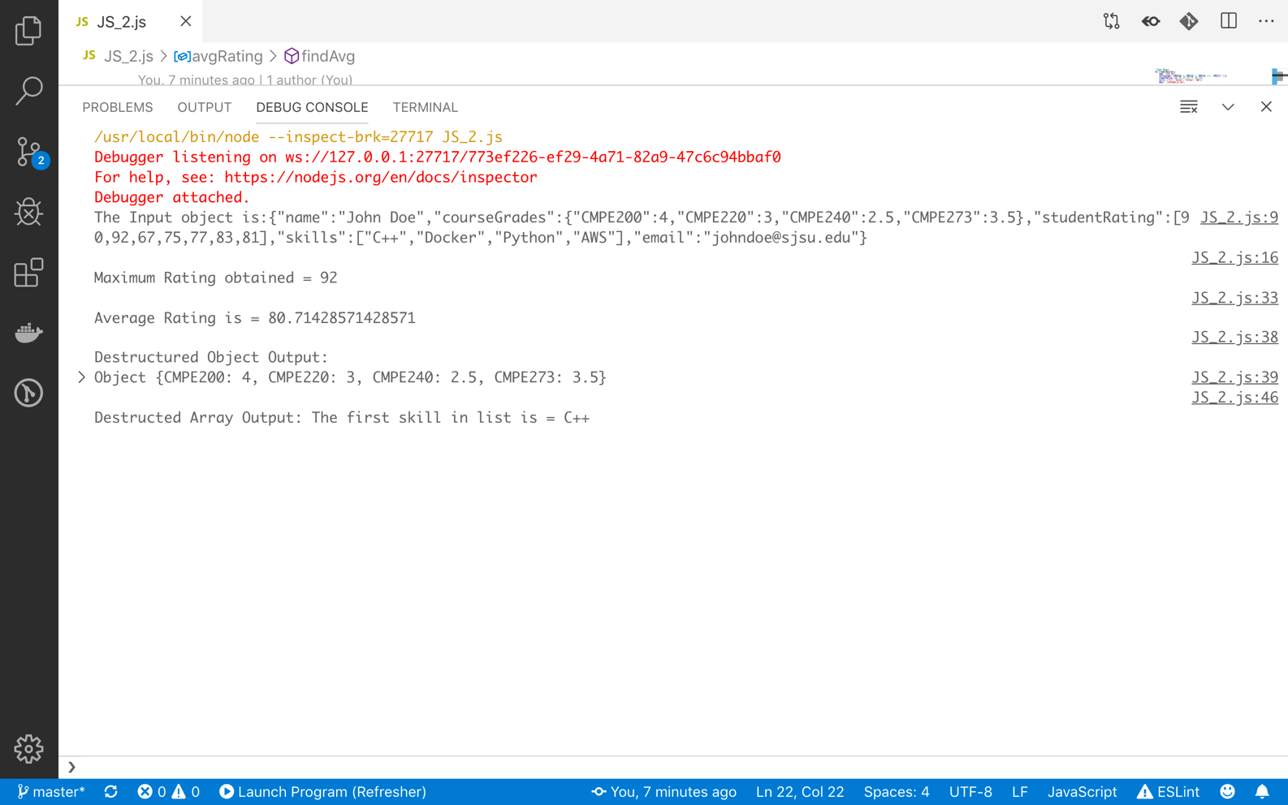

# JavaScript 3

## Question:

Create a Javascript file with a class that has 2 static methods. One static method takes 2 default parameters, which is email address and password. Another static method prints whether the email and password are valid or not. User regular expressions in the appropriate function to validate the username and password entered. Create another file that imports the class created in the previous file and displays the output when run.

## Code:

//JS_3_class.js

module.exports = class RegisterValidation {

//Static Function

// Defaul parameters used. Change these to change the checked password.

static fieldValidation(email = "johndoe@gmail.com", password = "12345@PASSword") {

//Regex for Email and Password validity check

let validEmailRegex = new RegExp(/^\w+([\.-]?\w+)*@\w+([\.-]?\w+)*(\.\w{2,3})+$/);

let validPassword = new RegExp("^(?=.*[a-z])(?=.*[A-Z])(?=.*[0-9])(?=.*[!@#\$%\^&\*])(?=.{8,})");

//Print Input

console.log("Input Email = " + email)

console.log("Input Password = " +password)

return [validEmailRegex.test(email) , validPassword.test(password)];

}

//Static function for output

static output = (emailFlag, passwordFlag)=>{

if (emailFlag == true && passwordFlag == true) console.log("Email and Password are Valid.");

else if(emailFlag == false && passwordFlag == true) console.log("Email entered is invalid.");

else if(emailFlag == true && passwordFlag == false) console.log("Password entered is invalid.");

else console.log("Both email and password entered are invalid.");

}

}

//JS_3_main.js

//Import Class

var importedClass = require('./JS_3_class')

//Store 2 return values

let [emailFlag, passwordFlag] = importedClass.fieldValidation();

//Use return values in output

importedClass.output(emailFlag, passwordFlag);

## Output:

# JavaScript 4

## Question:

## Code:

## Output:

# JavaScript 5

## Question:

Use fetch method to get the latest block information of the Bitcoin blockchain. Display the output in JSON format.

## Code:

//Fetch Blockchain API from blockchain.com

// This returns the latest Bitcoin block information

const fetch = require("node-fetch");

fetch('https://blockchain.info/latestblock').then(function (response) {

return response.json();

}).then(function (myJson) {

console.log(myJson);

});

## Output:

# JavaScript 6

## Question:

## Code:

## Output:

# HTML5 1

## Question:

## Code:

## Output:

# HTML5 2

## Question:

## Code:

## Output:

# Deployment

## Question:

## Code:

## Output: